Cricket Bets and scoreboard.

Tabbar based application

1. Home
2. Poll
3. My Profile
4. Home

* Show the team name in the table view cells.

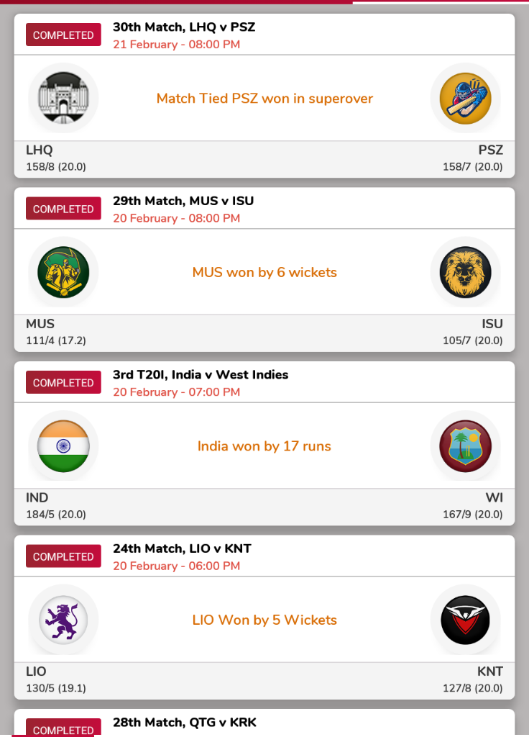

JSON filename - complete_match_data.json

1. Clicking on any match will show the details scoreboard.

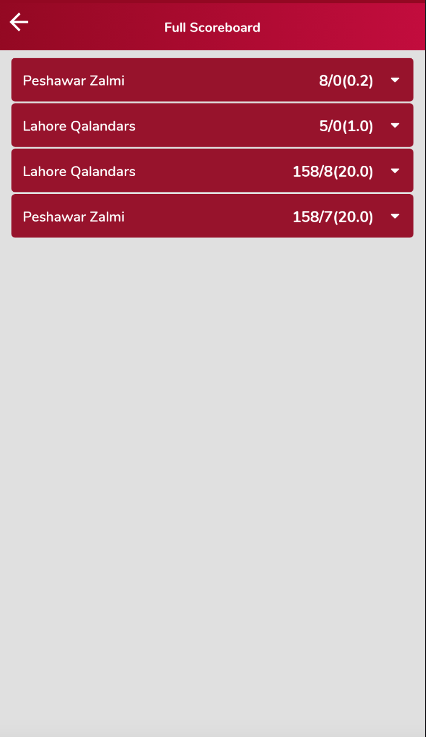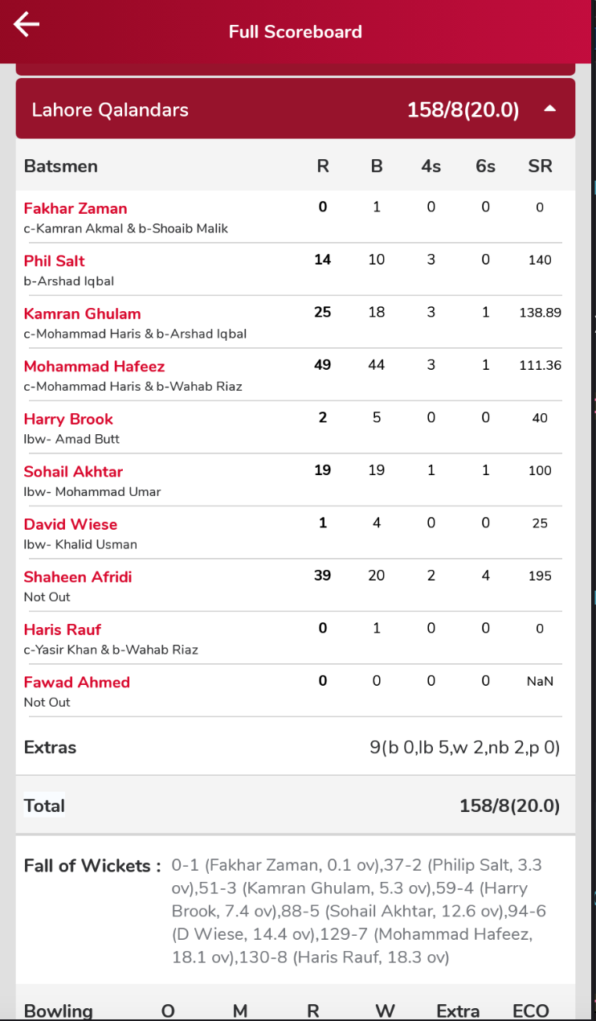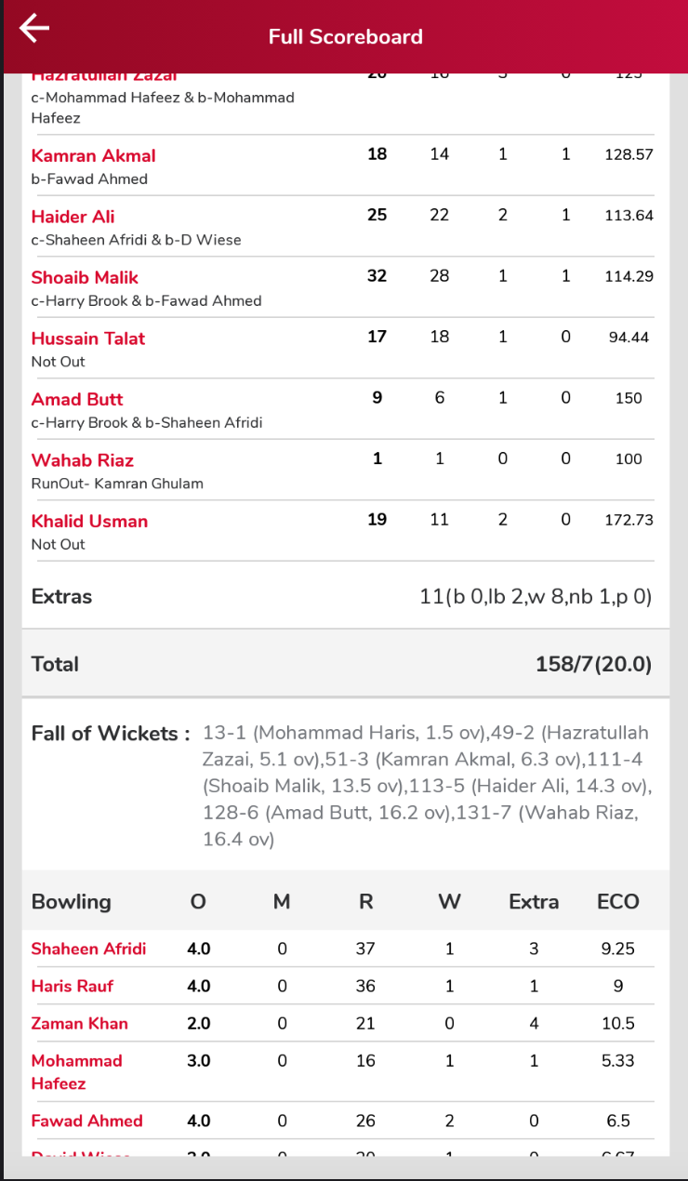

2. Poll

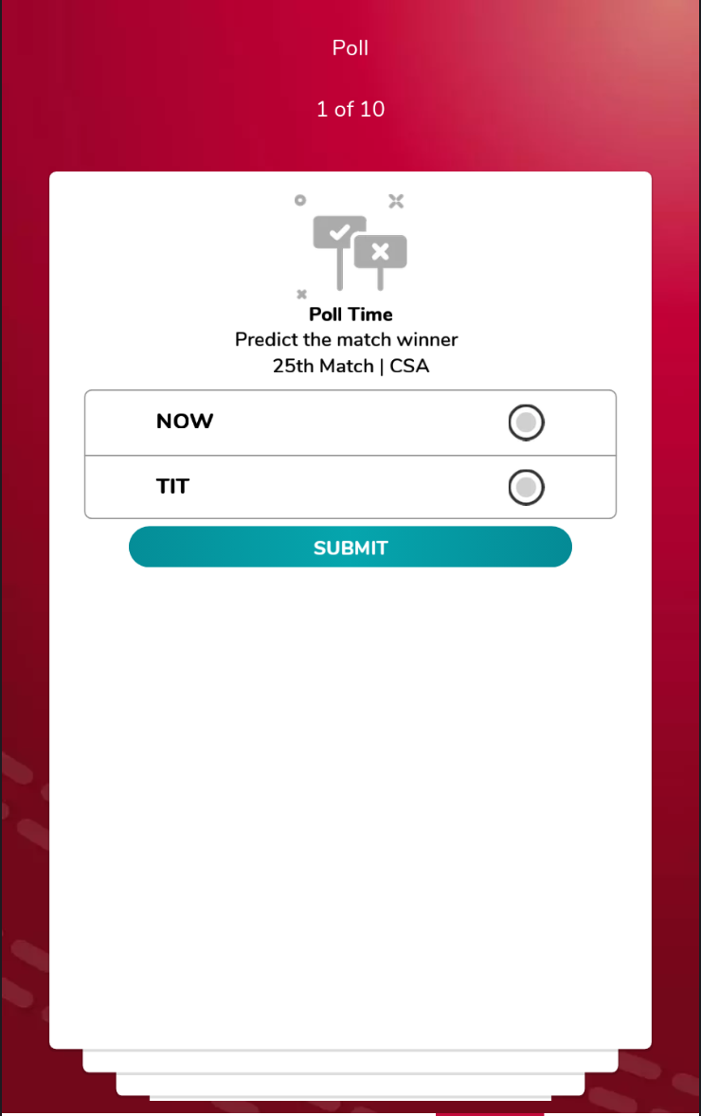

3. Profile

